Bloom’s Taxonomy
Level | Definition | Verbs
Create (CR) | Put parts of information together; create new information | create, design, synthesize,  develop, plan, support
Evaluate (EV)  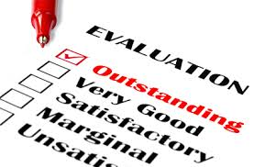 | Judge value or use of information based on criteria | argue, defend, justify,  predict, support, evaluate
Analyze (AN)  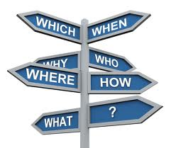 | Identify parts of information and see patterns | analyze, examine, experiment,  organize, compare, contrast
Apply (AP) | Transfer information from one setting to another; apply skills | apply, classify, illustrate,  solve, complete, develop
Understand (UN) | Grasp meaning of information | describe, explain,  identify, restate
Remember (RE) | Recall or recognize information | list, define, tell,  show, label

